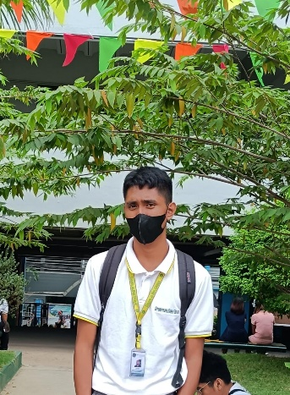

Christian Ejay H Clariño

**Information Technology**

# CONTACT INFORMATION

* 09353439396
* [clarinochristian052@gmail.co](mailto:clarinochristian052@gmail.co) m

## PROFILE SUMMARY

I am a freshman student taking the Bachelor of science in Information Technology.

I am currently learning about a programming language, Python. I am an active person especiallyI in my studies. I am good at collaborating with my classmates, and I help solve problems together. I am looking forward to learning further to reach my goals.

## EDUCATION & CERTIFICATION

**YOUR PROGRAM OR DEGREE TITLE**

Name of your school | Length of time you studied

## YOUR CERTIFICATION TITLE

Name of your certiﬁcate | Length of time you studied

## WORK EXPERIENCE

●

N/A

●

# PORTFOLIO TECHNICAL SKILLS

* Program
* Coding

# WORK TOOLS

* Python.
* Java
* Html
* Css

# CORE WORK SKILLS

* Team Cooperation
* Adaptability
* Problem Solver
* Active Listener

## PROJECTS

## Creating a System

**ACTIVITIES**

**Defense A System**

**Cashiering System**

**Websites**